**User manual for the A2E_App**

Yuntao Tian

August 3, 2023

1. Running the app

Run the app by right-clicking the script “A2E_App.mlapp” script and select ‘run’.

1. Input DEM and age data

The modeling requires the following inputs: a DEM file that covers a larger area than the samples, the thermochronologic age data (that must include sample latitude, longitude, elevation, age, error). Notes all elevation data should be in meters. These two input data files can be loaded by clicking the first to buttons. Once uploaded, the DEM and age-elevation relationship will be plotted in the panels to the left (Figure 1).

The example data folder “Fitzgerald1995” contains the DEM input “DEM_Fitzgerald1995.csv”, which has three columns of xyz. This DEM is generated from the SRTM10 data set. The “DATA_Fitzgerald1995.csv” is the example input age data.

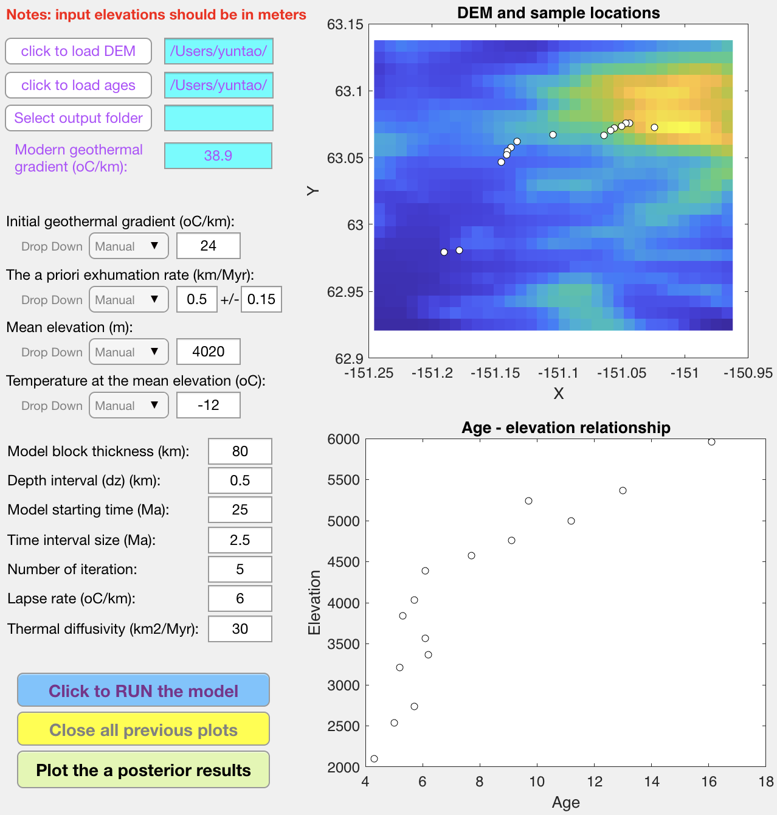

Figure 1. A screen shot of the app after uploading the DEM and age data.

1. Selecting the output folder

Selecting a directory for saving all model outputs by clicking the ‘Select output folder’ button. The selected directory will be printed in the space to the left of the button. Note that after selecting the age input data and output folder, the program can plot the outputs of previous run. This can be useful for reviewing previous models.

1. Model geothermal constraints

The modern geothermal gradient is the only constraint for the geothermal field. It can be defined by inputting a value in the space to the left of the text “Modern geothermal gradient (oC/km):” In general, given a certain age-elevation input, a high modern geothermal gradient would result in systematically lower exhumation. But the pattern of the exhumation history would not change.

1. Model setups

The initial geothermal gradient (G0) can be either searched by the model, if selecting ‘Auto’ in the corresponding drop-down window (Figure 2). If so, the model will run a set of models using different G0 values (changing between 0.6 – 1.2 times of the modern value) to find the one that provide the best fit to the observed age data. The other option is to select ‘Manual’ in the drop-down window (the default option), and input a specific value.

Similar to the options for G0, the a priori exhumation rate (e0 +/- sigma0) can also be searched by the model, if selecting ‘Auto’ in the corresponding drop-down window. If so, the model will run a set of models using different G0 values (changing between 0.3 – 1.5 times of the value determined from the nominal closure temperature and modern geothermal gradient) to find the one that provide the best fit to the observed age data and modern geothermal gradient. The other option is to select ‘Manual’ in the drop-down window (the default option), and input a specific value.

In a similar manner, the mean elevation (m) and the corresponding temperature (oC) can be either set as ‘Auto’ or ‘Manual’. If set as Auto, the mean elevation will be calculated as the mean of the DEM, and the Temperature at the mean elevation (oC) will be calculated as 25-lapse_rate*mean_elevation. Otherwise, manual inputs are required.

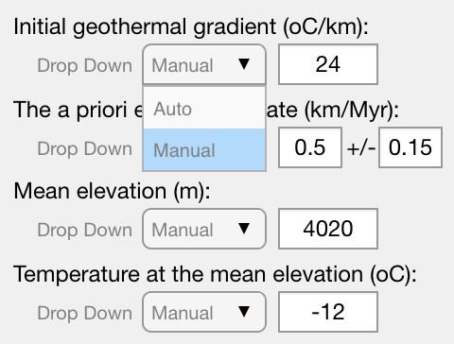

Figure 2. Options for automatically and manually set up the initial geothermal gradient, the a priori exhumation rate, the mean elevation (m) and the corresponding surface temperature (oC).

1. Other setups

Other setups are straightforward. ‘Model block thickness (km)’ is the thickness of the model block, where the closure depths will be determined. The ‘Depth interval (dz)’ is used for numerically calculating the 1D geothermal field. A smaller value (<1 km) provides a better model precision, but will significantly influence the speed of the modeling. A value between 0.2 – 1.0 is reasonable, in terms of model speed and precision.

‘Model starting time (Ma)’ is the onset time for determining the exhumation history, with a specific ‘time inverval size (Ma)’.

The closure depth is a non-linear function of rock cooling and exhumation. Therefore, the problem of interest is non-linear, which can be addressed by iterative numerical modelling methods. In this work, the solution of exhumation is approximated by coupling and iterating the linear inversion and closure depth modeling. As shown in Tarantola (2005) and Fox et al. (2014), the algorithm converges in a few (3-5) iterations and produces stable outputs.

Atmospheric ‘Lapse rate’ and ‘Thermal diffusivity (km2/Myr)’ of the model block are common parameters for modeling the geothermal field.

1. Run the model by clicking “Click to RUN the model”
2. Any previous plot can be closed by clicking “Close all previous plots”
3. After running the model, the results can be displayed by clicking “Plot the *a posterior* results”, which will generate a set of subplots showing the comparison of ages, exhumation history, model resolution and correlations. If the initial geothermal gradient (G0) and the a priori exhumation rate were set as “Auto”, multiple models will be run. But the figure generated by “Plot the *a posterior* results” would only plot the one that provide the best fit to the observed ages and modern geothermal gradient.
4. After plotting, the figure can be exported as vector (.pdf, .eps) and bitmap (.jpg, .png) files by clicking ‘File’ and then ‘Save as’ from the top line of the plot window.
5. Exiting the app by close the app window.

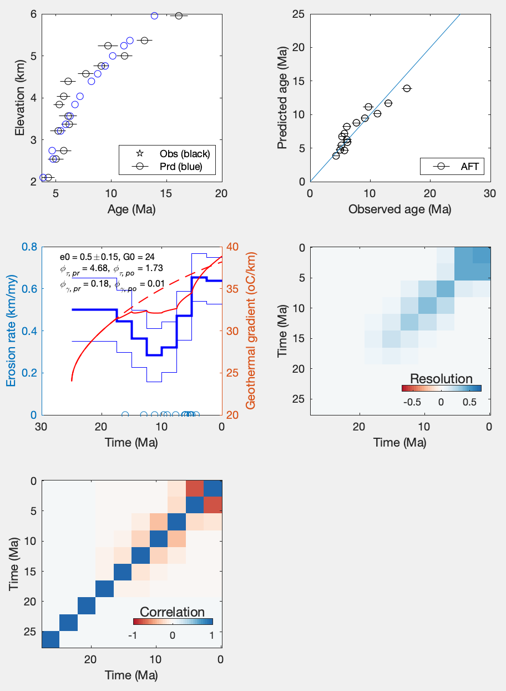

Figure 3. A screen shot of subplots of model outputs. Upper left: Comparison between the observed (in black) and predicted (in blue) AER. Upper right: plots of observed and modeled ages. Middle left: Histories of exhumation and geothermal gradients. The blue thick and thin lines are the mean and one standard deviation of the inverted exhumation history. The red dash and solid lines are the history of the geothermal gradients, predicted by the *a priori* and *a posterior* models, respectively. Middle right and lower left: Plots of the resolution and correlation matrix.